ASSIGNMENT 1

Q1: Connect and disconnect with login Access

* What happens when you login a non-existent users or username?
  + Provide Screenshot and What you understand, explain in short brief?

We don’t get the access of the machine as user does not exists.

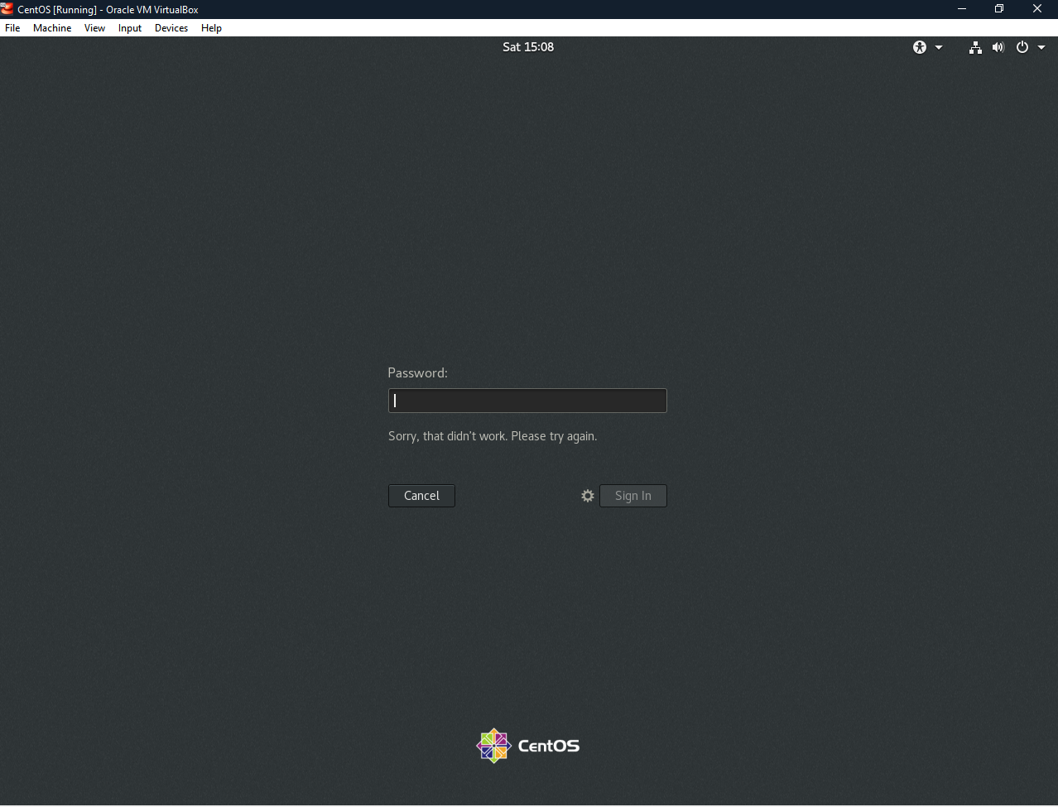

Q2: Password changing

* Login into your account and then change password?
  + Change your password into ***IneuR0n#42*** and hit the **Enter** key
    - Explain what happen and give screenshot?

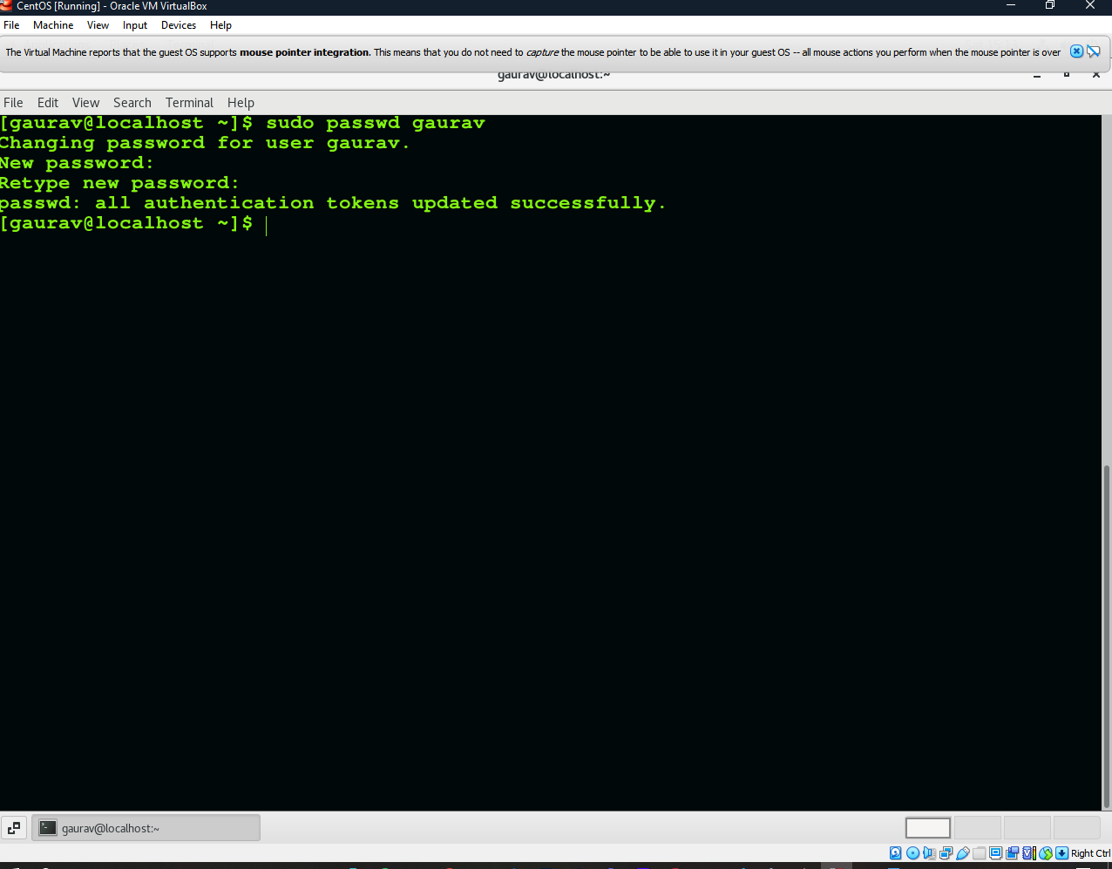

I used sudo to change the password, it prompted to enter the password twice and it got changed.

Try again to change password but use like password ***1234*** or ***abcd***

* + - Explain what happen and give screenshot?

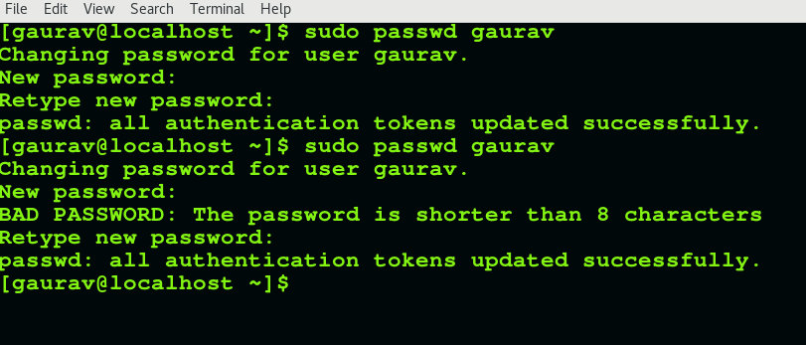

It gives a warning for bad password but changes it as we are executing this as a sudo command.

* + Try again to change password but now don’t use any password just hit **Enter** key
    - Explain what happen and give screenshot?

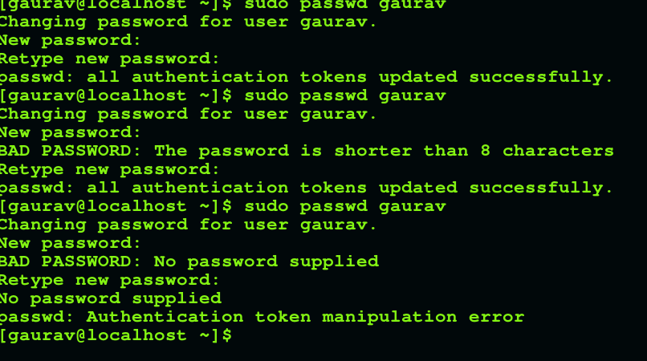

It gives this error when only enter is pressed as password.

Assignment-3

Working with Directories

* Enter the command **cd /** and then **ls** and then hit **Enter** key
  + Take screenshot and explain what output we got?

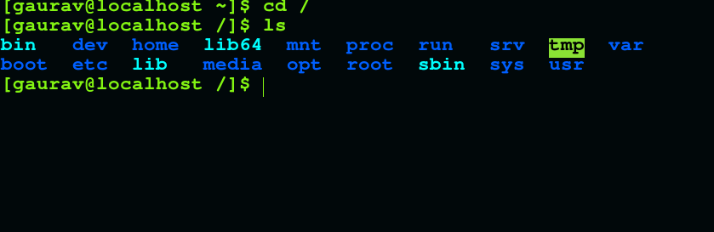

* Enter the command now **cd /home** and then hit **Enter** key
  + Do **ls,** provide screenshot and explain what is **/home** directory used for?

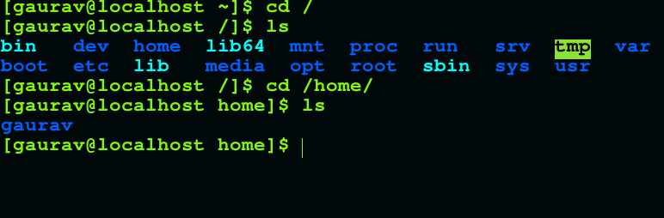

This time home directory for the user gaurav opens up which generally stores the user profile data for the gaurav user.

* Enter **cd ..** and hit **Enter** key [ *Note: here we have space after cd then use double dot*]
  + Check what happen and give screenshot?

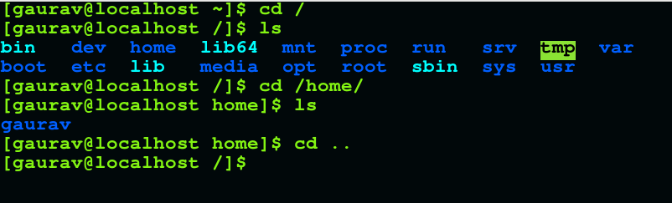

The prompt goes back to the parent directory i.e one level back.

* Now enter **cd /var/www/html** and then type **cd** and hit **Enter** key
  + Explain what happen and give screenshot?

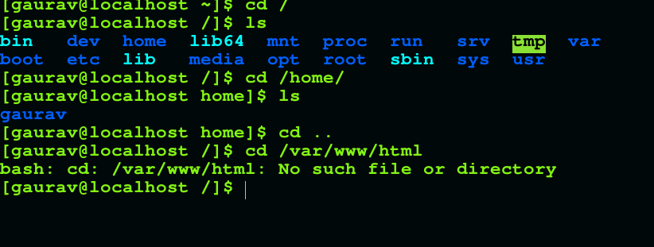

Path not found as the web server is not installed.

* Now type **cd /root** and then hit **Enter** key

Do **ls,** check any output we have on screen if yes then take screenshot?

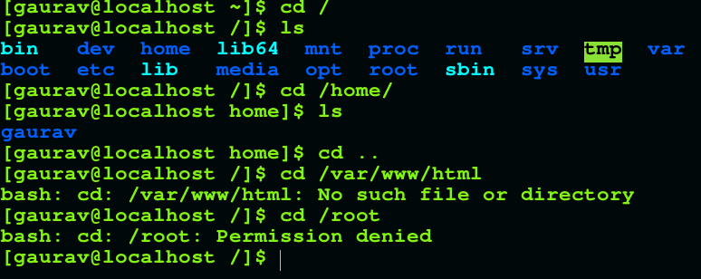

Permission is denied to the gaurav user as sudo is not used here.

Assignment-4

Working with File Listing

* Go to **cd /etc** and type **ls**
  + Take screenshot and explain what files you have seeing?
  + Take screenshot and explain what different output you found compare to previous command you used?

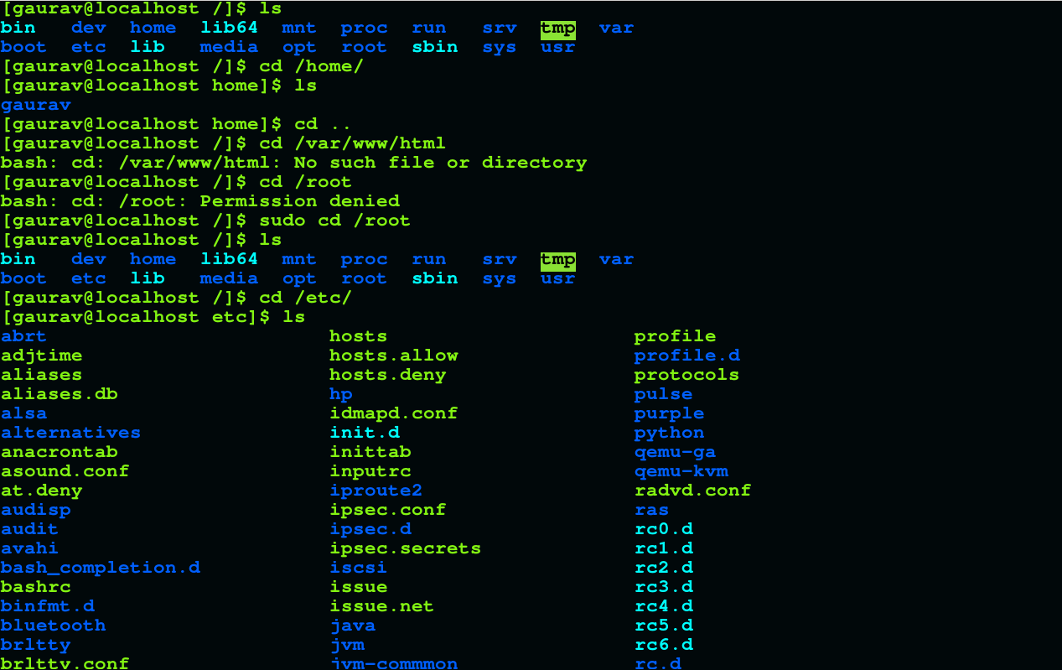

Multiple folders have been listed as etc directory contains all the configuration related data for the machine.

* Then type **ls -al** and hit **Enter** key
  + Take screenshot and explain what new file or directory you found?

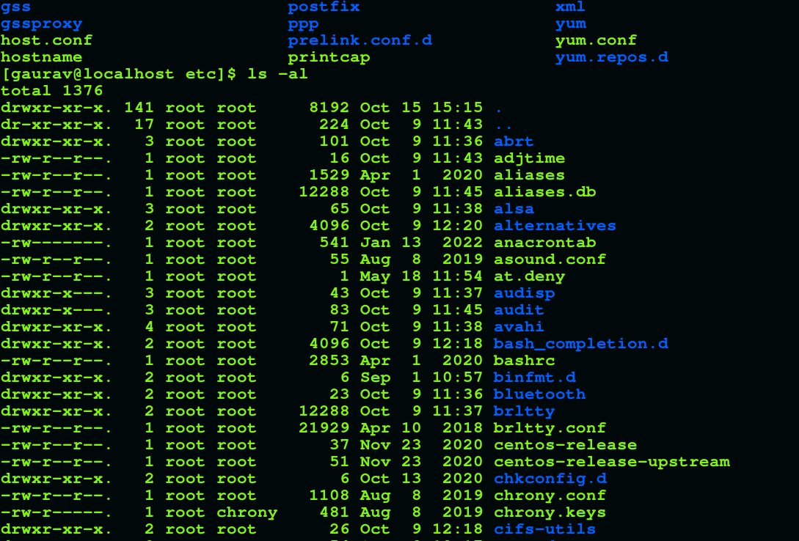

All the files and folders have been listed with their permissions and other attributes.

* Then use **ls -i** and hit **Enter** key
  + Now see what different output its shows and take screenshot?

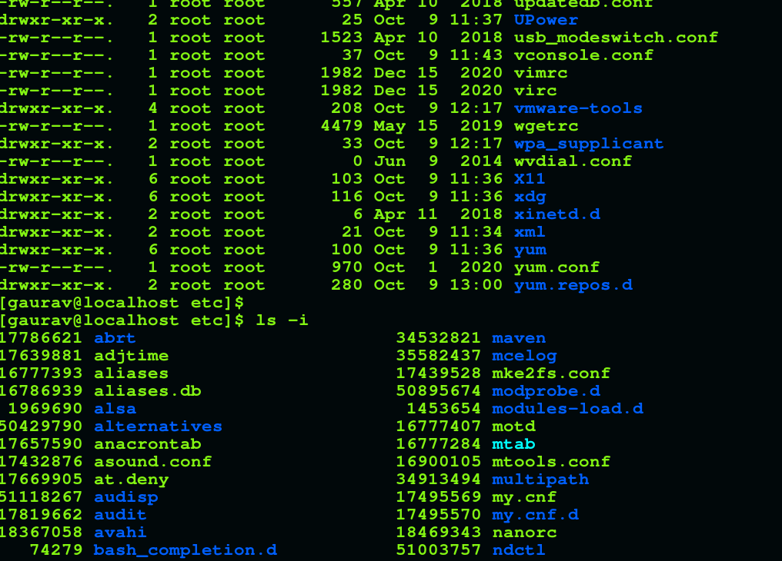

It lists the files along with the inode number for the particular file type.

* Then use **ls –help** and see other options about **ls** command

Explore it and try with other attribute we can use with **ls** command

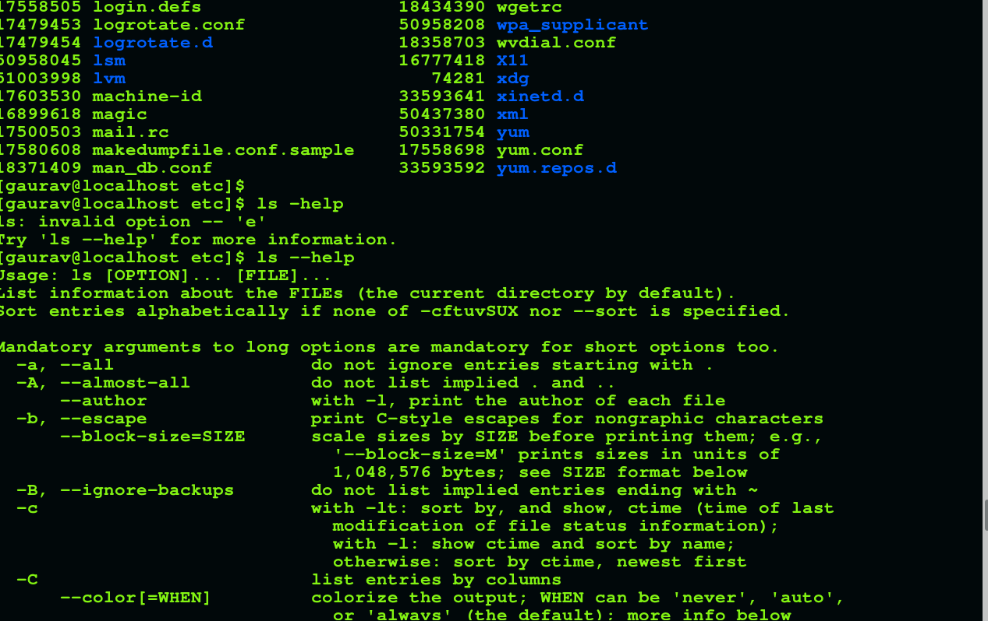

It opens up the help page for ls command.

Assignment-5

Know where you are and where you working

*Here we use* ***pwd, cd and ls*** *as combine task to understand where you working on terminal and how you can switch from one directory to another one.*

* Open terminal after restart the linux
  + Check which location you working, type **pwd** and take screenshot

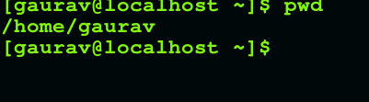

* Now use **cd /var** and hit **Enter** key
  + Do **ls,** and see what output comes, give screenshot?

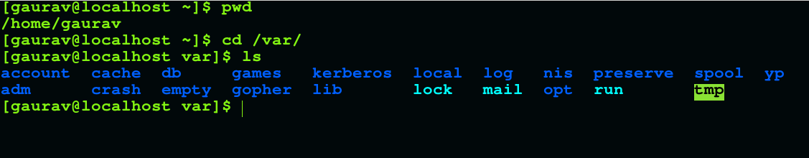

It lists all the folders under the var directory.

* Do explore other help options of each command to learn more other things we can do with these commands

NAME: GAURAV MAURYA

EMAIL: [THECHAOTICBUDDHA@GMAIL.COM](mailto:THECHAOTICBUDDHA@GMAIL.COM)

DATE: 15/10/2022